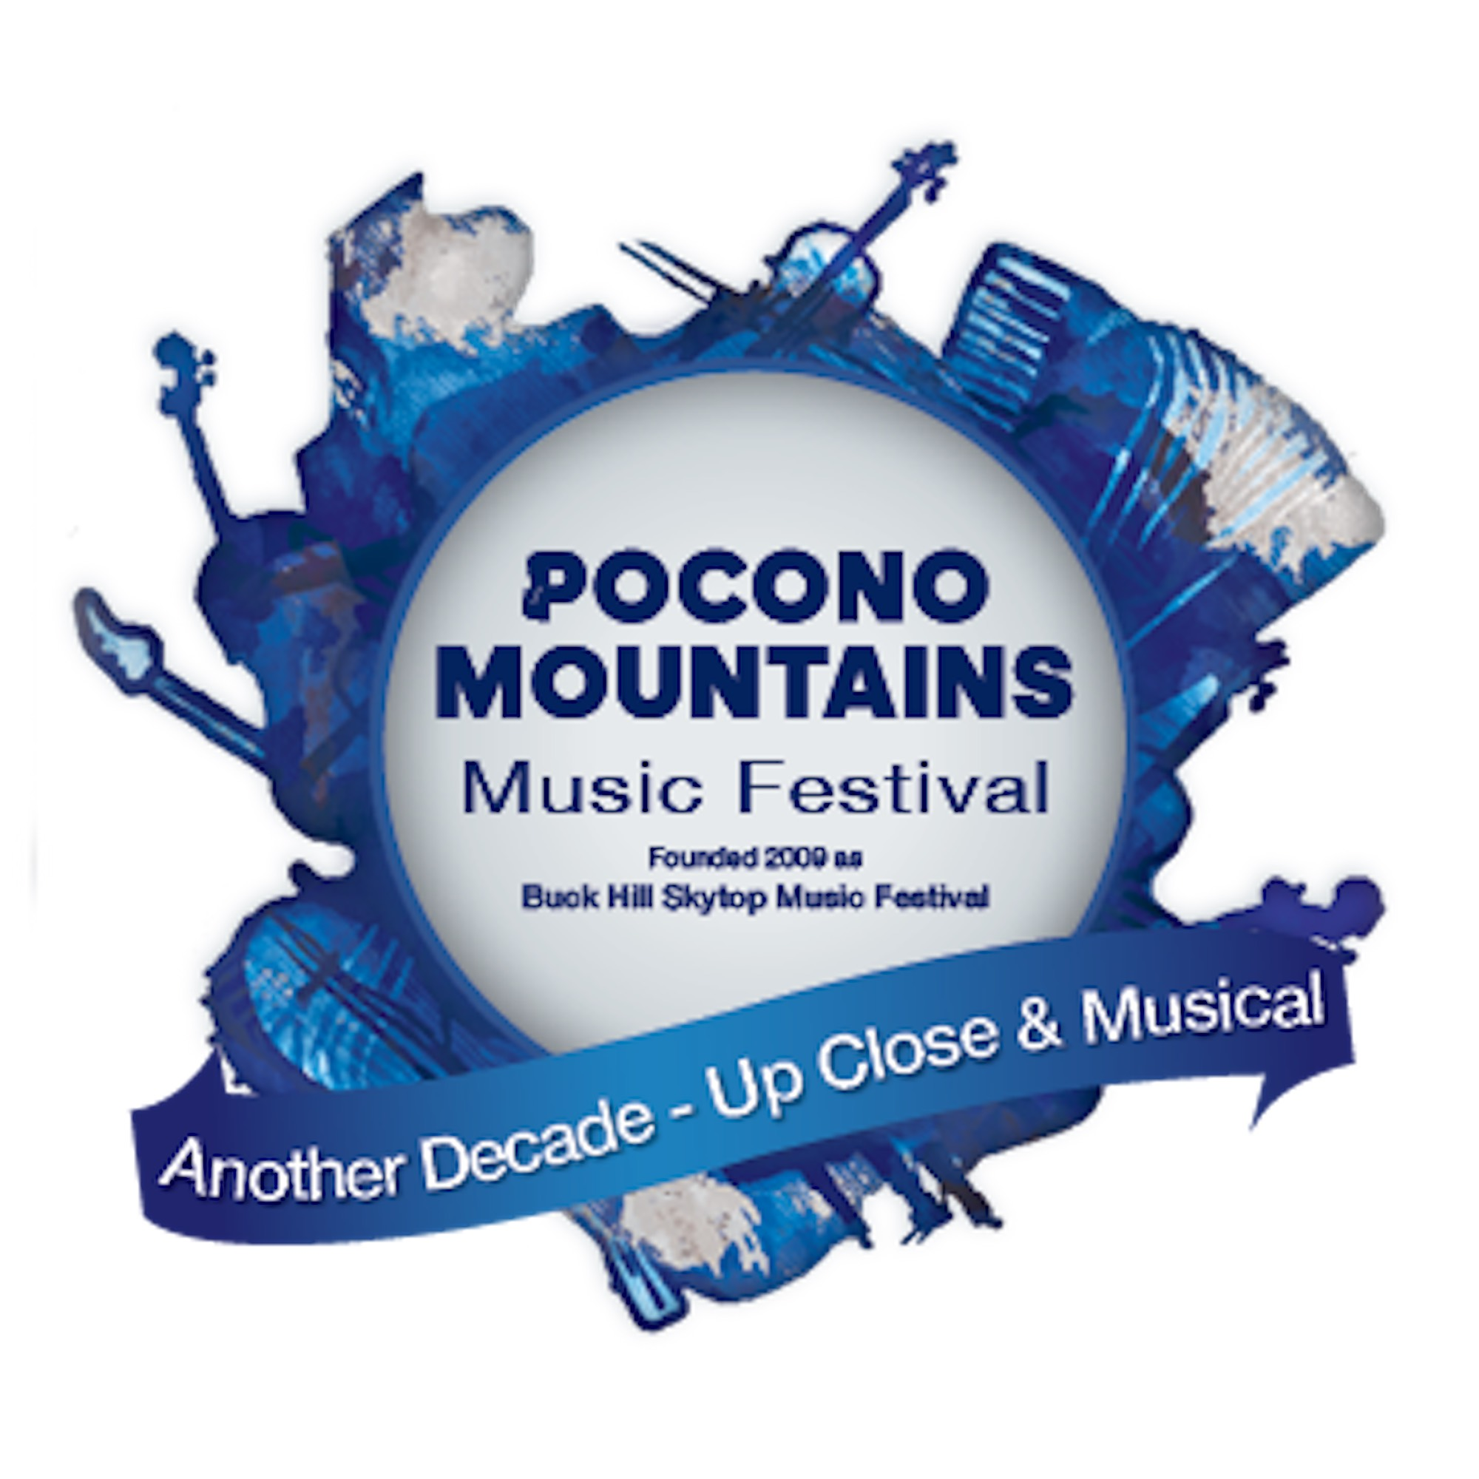
Sponsorship Form

Event Sponsor’s Name: Click here to enter text.
(Business, Organization or Individual)

Contact Person: Click here to enter text.
(Name and Title)

email: Click here to enter text. phone number: Click here to enter text.

Mailing Address: Click here to enter text.

Level of Sponsorship: Click here to enter text.

Purpose of Sponsorship:
☐ Unrestricted
☐ Pocono Mountains Music Festival Programming 2020-21 Season
☐ Education Programming Only
☐ Other: Sponsorship of the Pocono Mountains Music Festival production of: Pocono Mountains High School Musical … A Virtual Extravaganza!

Authorizing Person’s Signature:______________________________________
(Name and Title)

Please send sponsorship donation and correspondence to:

Pocono Mountains Music Festival
PO Box 605
Mountainhome, PA 18342-0605

Sponsor Level $5000+
- Acknowledgment at the beginning of the Pocono Mountain High School Musical livestream / broadcast with language to the effect of: “underwritten by or presented by”, inclusion of the sponsor logo if so desired
- Acknowledgment in all media promoting the Pocono Mountain High School Musical with language to the effect of “underwritten by or presented by” and, where appropriate, inclusion of the sponsor logo if so desired
- Acknowledgement on the Pocono Mountains Music Festival Website as a sponsor underwriting or presenting the Pocono Mountain High School Musical
- Acknowledgement in the 2020-21 season’s program of underwriting or presenting the Pocono Mountain High School Musical

Sponsor Level $1000 - $4999
- Acknowledgment at the conclusion of the Pocono Mountain High School Musical livestream / broadcast with language to the effect of: “a special thanks to donors”
- Acknowledgement on the Pocono Mountains Music Festival website: “With special thanks to donors supporting the Pocono Mountains High School Musical.” (smaller font than $5000+ Sponsor)

Sponsor Level under $1000
- Acknowledgment with all other donors of equal amounts with the notation “supporter of Pocono Mountains High School Musical”.

